Abu Dhabi Appartments

Applied Data Science Capstone Project

Mohammed AL Rifai

* In this project, we will help people who are looking for renting an apartment in Abu Dhabi. If they are looking to move to Abu Dhabi they can see:
  + Which district has cheaper rent or to have an idea on how the prices effected per district or number of rooms, services , size..etc
* The data on apartments: size, number of rooms, address, and the price is collected by scraping a local website with apartment listings (dubizzle.com). We clean up the values and did data pre-processing:
  + In total 900 apartments with data like size, number of rooms, address, and price
* Using geopy coordinates for each district are obtained
* Foursquare data to collect top 10 venues for each district

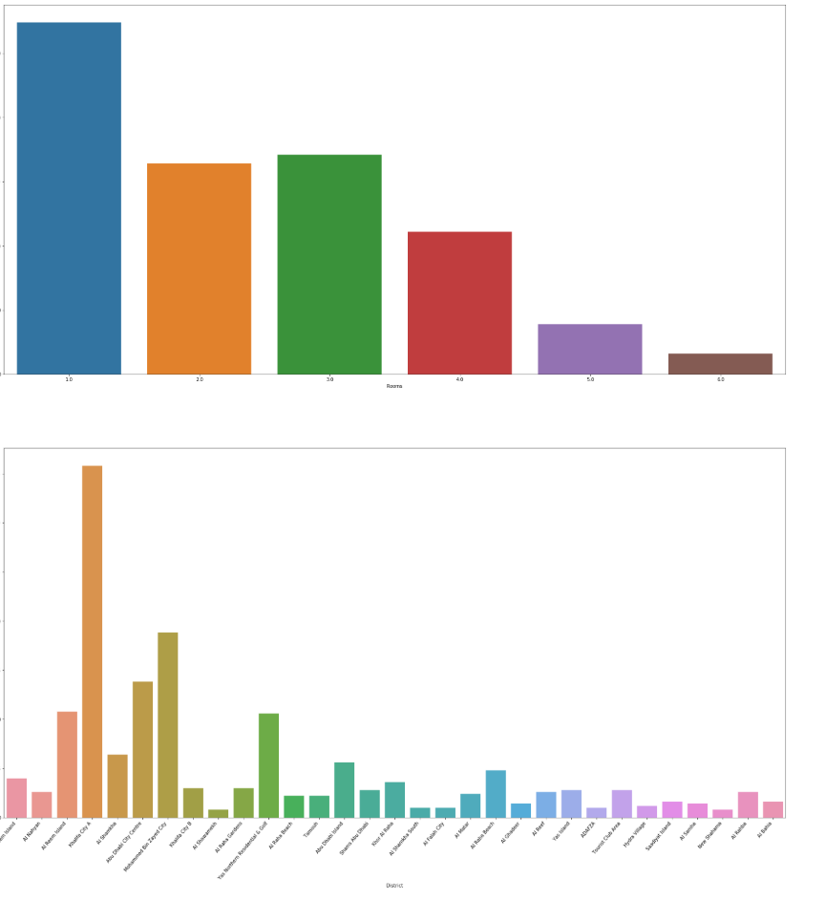

From this we can see that 1 and 3 room apartments are the most common.

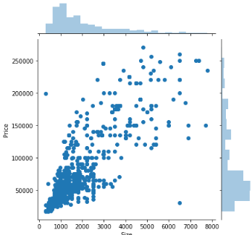

Correlation between the price and apartment size. As expected, the larger the apartment, the higher the monthly rent

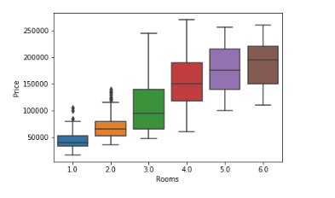

We expect the value of properties to go up as the number of rooms increases. The interesting aspect in this boxplot is that 1 and 2 room apartments are competing in the same price range.

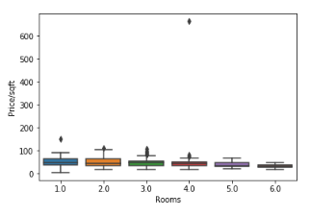

The price/m2 is in the same price range for all size apartments besides for single room apartments where the price/sqft goes even higher.

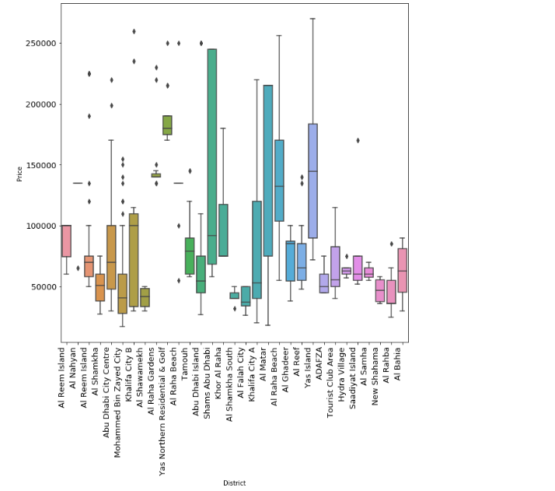

Using the apartment data and the we can visualize the average price ranges for each district in Abu Dhabi.

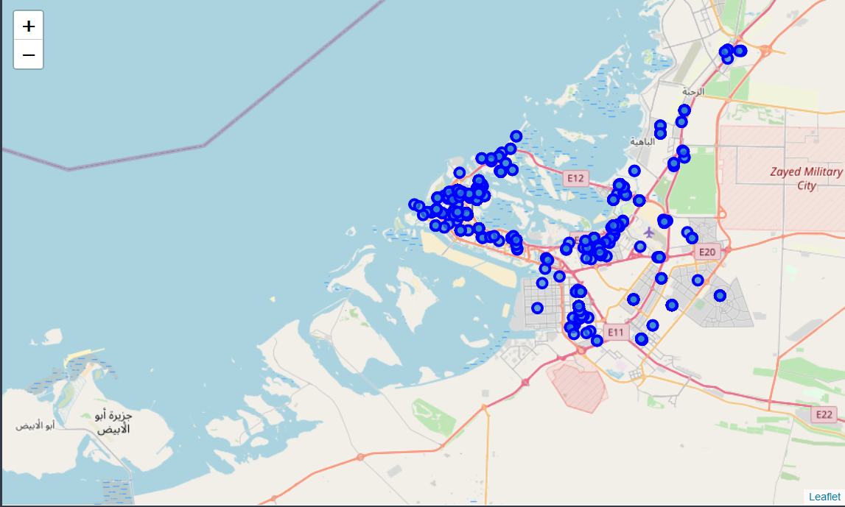

Using the maps we can show the apartment location with description

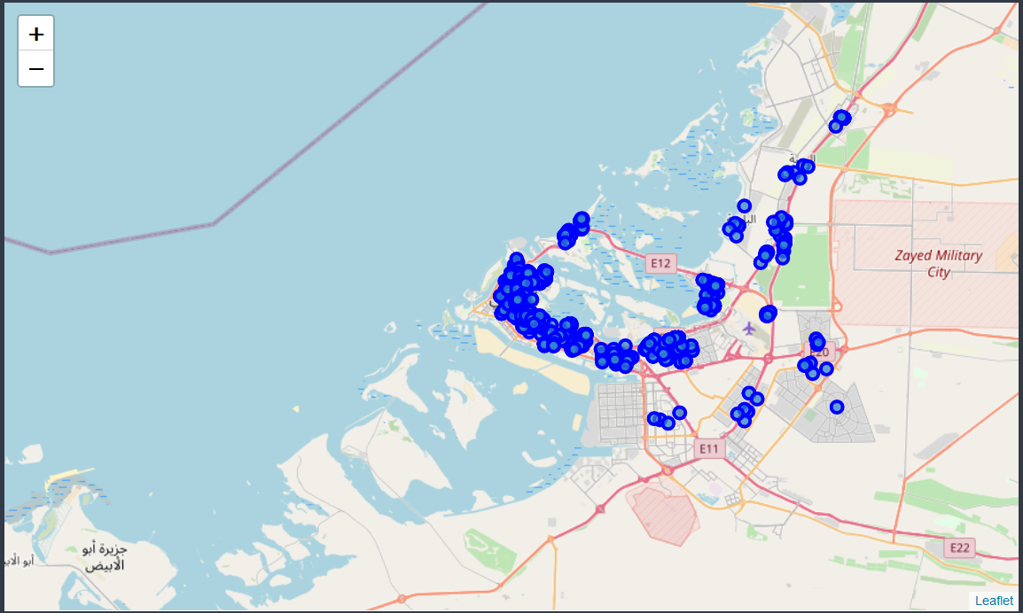

Using the maps and foursquare we can show the Venues location with description

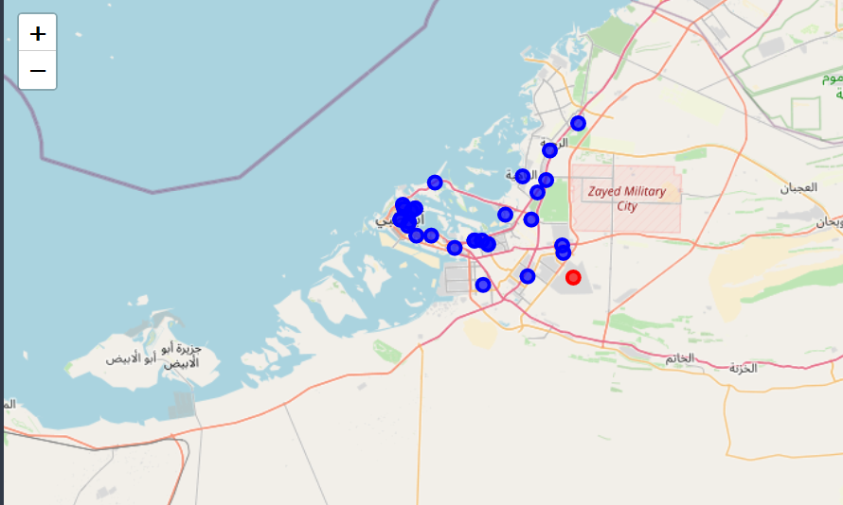

We can noticed that the red cluster is the most district which has less services like supermarket and …

Once Foursquare data is collected. We find the most common venues (supermarket, restaurant, park, etc.) and select the top 10 venues for each district. After the data collection we can run k-means clustering to cluster the districts. By analyzing the clusters we can see that cluster 1 is more residential since it contains lots of parks and supermarkets.

# Discussion & Conclusion

With this our analysis, one could determine for example that the 1st district is the best district to live in, however by clustering we determined that there are several more similar districts where the price/sqft is significantly lower.

* for renting apartments.